A Web Based Event Discovery Platform for Nairobi Residents

189982
189539
ICS Group: C

Supervisor: Salome Monthe

An Informatics and Computer Science Project Proposal Submitted to the School of Computing and Engineering Sciences (SCES) in partial fulfilment of the requirements for the award of a Bachelor of Science Degree in Informatics and Computer Sciences

School of Computing and Engineering Sciences
Strathmore University
Nairobi, Kenya

May 2026

Declaration
We declare that this work has not been previously submitted and approved for the award of a degree by this or any other University. To the best of our knowledge and belief, the research proposal contains no material previously published or written by another person except where due reference is made in the research proposal itself.

Student Name: Jason Francis Mageto
Admission Number: 189982
Signature:__________________________ Date:_______________________

Student Name: Joypraise Mutwiri Kendi
Admission Number: 189539
Signature:__________________________ Date:_______________________

Supervisor Name: Salome Monthe
Signature:__________________________ Date:_________________________

Abstract
Nairobi’s event scene is a sector that is continuously growing and thriving. Many eligible people attend these events in numbers, unifying citizens as they revel together. However, the advertisement and marketing of these events is quite limited; mostly being only on social media platforms.
This project is an ideal web-based system to facilitate users receiving updates and information about upcoming events, while also providing ticketing services to purchase tickets for the said events. This enables wider reach among Nairobi residents who do not have access to social media accounts. Existing websites like Eventbrite offer similar services but our system contains added functionalities such as automatic ride booking for events to enhance user experience.
The system has been developed using OOAD. Technologies that were used in the development include React for the frontend, Node.js and Maria DB for the backend and database, and Postman for creating and testing APIs; with more tools being used in tandem. Users are able to view events and purchase tickets, while administrator(s) of the website are responsible for maintaining website functionality. The success of the system is evaluated via user feedback and system testing, as well as comparisons with existing systems.

Table of Contents
Declaration ii
Abstract iii
List of figures vii
List of abbreviations viii
Chapter 1: Introduction 1
1.1 Background Information 1
1.2 Problem Statement 2
1.3 Objectives 3
1.3.1 General Objective 3
1.3.2 Specific Objectives 3
1.3.3 Research Questions 3
1.4 Justification 3
1.5 Scope 4
1.6 Limitations 4
1.7 Delimitations 4
Chapter 2: Literature Review 5
2.1 Introduction 5
2.2 Event Discovery and Management in Nairobi 5
2.3 Current Processes of discovering and managing events in Nairobi 5
2.4 Challenges in Current Approaches to Event Discovery 6
2.5 Related Applications 7
2.5.1 Eventbrite 7
2.5.3 Facebook events 7
2.6 Gaps in current Approaches and Related Applications 8
2.7 Technologies Related to the Study 8
2.7.1 Daraja (Safaricom Developer Portal) 8
2.7.2 Uber APIs 9
Chapter 3: Methodology 10
3.1 Introduction 10
3.2 System Methodology 10
3.2.1 Requirements Gathering 11
3.2.2 Design 11
3.2.3 Development 11
3.2.4 Testing and Debugging 11
3.2.5 Deployment 11
3.2.6 Review 11
3.3 System Analysis 12
3.3.1 Use Case Diagram 12
3.3.2 Class Diagram 12
3.3.3 Context Diagram 12
3.3.4 Entity Relationship Diagram 12
3.4 System Design 13
3.4.1 Database Schema 13
3.4.2 Wireframes 13
3.4.3 System Architecture 13
3.5 System Development Tools and Technologies 13
3.5.1 React.js 13
3.5.2 Node.js 14
3.5.3 MySQL 14
3.5.4 GitHub 14
3.5.5 Postman 15
3.6 Deliverables 15
3.6.1 Authentication Module 15
3.6.2 Events Module 15
3.6.3 Organiser Module 15
3.6.4 Transport Module 15
Chapter 4: System Analysis and Design 16
4.1 Introduction 16
4.2 System Requirements 16
4.2.1 Functional Requirements 16
4.2.2 Non-Functional Requirements 18
4.3 System Analysis Diagrams 19
4.3.1 Use Case Diagram 20
4.3.2 Context Diagram 20
4.3.3 Class Diagram 21
4.3.4 Entity Relationship Diagram 23
4.4 System Design 23
4.4.1 Database Schema 23
4.4.2 Wireframes 24
4.4.3 System Architecture 26
References 27
Appendix 29

List of figures
Figure 1: Conceptual Model 9
Figure 2: Steps in Agile Software Development (What is Agile Development?, 2021) 10
Figure 3: Use Case Diagram 20
Figure 4: Context Diagram 21
Figure 5: Class Diagram 22
Figure 6: Homepage Wireframe 24
Figure 7: Event Detail Page Wireframe 25
Figure 8: Checkout Page Wireframe 25
Figure 9: System Architecture 26
Figure 10: Gantt Chart showing progress of the system’s development 29

List of abbreviations
OOAD – Object Oriented Analysis and Design
API – Application Programming Interface
PK – Primary Key
FK – Foreign Key

Chapter 1: Introduction

Background Information
Nairobi’s County, the capital city of Kenya, is home to one of the most diverse event scenes in the country. There exists a very high demand for the diverse array of events take place in the city, for all ages and tastes. Nairobi has had a history of hosting a variety of big events, including the coming of big-name artists like Asake and Burna Boy (Milimo, 2026), the Nairobi International Cultural Festival which offers people to come and showcase the vast culture that our country holds (Editor, 2024), GTR East Africa Conference which amassed over 600 attendees, summits, festivals, exhibitions, among others.
Major festivals and events have increasingly attracted local and international audiences, contributing to the country’s economy and continuous planning of events. Events such as the Nairobi Festival have drawn crowds of over 300,000 people from far and wide across different editions (nairobi.go.ke, 2022). Nairobi has also developed into a centre for innovation and networking events. Conferences and summits, such as the Afrinovation Festival showcase Nairobi’s ever-growing reputation as a business and innovation destination (Afrinovation Festival Nairobi, 2025).
The city’s nightlife and entertainment culture majorly contributes to the popularity of events in Nairobi. Areas such as Westlands, Kilimani, and Karen frequently host live music sessions, DJ performances, comedy nights, themed parties and social experiences that mainly attract young professionals, students and creatives. Online forums also show that residents purposefully seek social, networking and creative events as part of Nairobi’s urban lifestyle (whats-on-nairobi.com, 2026)
This collection of events in Nairobi is usually advertised and marketed to the public via advertisements on social media services, websites, newspapers, and billboards. However, social media remains the most used method to inform the public about upcoming events. People will come across posts and stories of events and visit attached links to purchase tickets. After this, they receive tickets virtually for attendance of the events.
Globally, the need for events websites has grown, necessitated by the growing demand to attend events by the public, and the economic demand by event companies to adequately market their events and earn profit from increased attendance. In Nairobi, several event websites exist that provide brief rundowns on upcoming events, while smaller number also provide ticketing services within the same website (ticketsasa.com, n.d.). Moreover, some events websites also act as organisers for the events themselves, bringing a wide range of artists to perform, or inviting guest speakers and renting venues for conferences and the like. Other people resort to purchasing these tickets from third-party sites or people, posing security risks to themselves.

Problem Statement
Nairobi lacks proper implementation of event websites, with existing websites often providing one specific functionality instead of cumulatively providing required functionality. One major issue facing event websites is ticket fraud. Counterfeit tickets offered by third-party resellers are often invalid or duplicated, preventing entry for paying attendees and reducing the overall attendance of specific events, thus losing revenue for organisers and dissatisfaction from the public (Abuya, 2025).
Additionally, existing websites struggle with high-demand events, especially when thousands of users access the platform simultaneously. Last minute rush for tickets can overload those websites, leading to website crashes where users cannot access or purchase tickets, failed payments and premature “sold out” messages due to poor transaction management, and slow checkouts. This often leads to many willing eventgoers to miss out on events due to poor development and management of such websites. This problem has frequently happened specifically with concert and major football ticket sales. (ARouterContinua, 2025)
Furthermore, the lack of a centralised advertisement source leads to scattered event discovery. With many events being marketed on social media applications, many users rarely discover events unless they specifically search for the organizer’s page; while coming across advertisements of these events requires a social media account. While many of Nairobi’s public have social media accounts, these advertisements are scattered across various social media apps and often exclusively appear under one platform, and people without accounts for that platform barely come across advertisements for that event. Users often discover events after they have already happened, and this widespread problem as been repeatedly mentioned by Kenyans (bingadeh, 2026).
On top of that, many event websites do not engage with their customers. Most platforms stop at ticket sales and offer little to no support for crowd analytics, check-in management, community engagement and post-event feedback. These gaps lead to lack of a reliable channel for users to provide feedback about services offered and the event itself, while lack of community engagement leads to limited exposure to new and similar events for the public, as well as events that match the taste of users of the platform.

Objectives

General Objective
To develop a functional and user-friendly web application that offers proper event marketing and ticket sale for events in and around Nairobi.

Specific Objectives
- To analyze existing event websites and improve on their weaknesses.
- To increase the number of people concurrently using the platform to 5 million.
- To design a web-based application for event organizers to advertise their events.
- To launch a prototype for Nairobi residents within 2 months.
- To implement various technologies to add functionalities that existing websites do not offer.
- To test accurately the functionality of the developed proposed website.

Research Questions
- What weaknesses and shortcomings do existing websites have?
- How many people can concurrently use existing platforms?
- How do event organizers currently advertise their events??
- Which development method and tools should be used to ensure the deadline for prototype release is met?
- What functionalities do existing websites lack?
- Which tools can be used to effectively test the website?

Justification
Many of Nairobi’s residents want to attend events, whether for entertainment or informatic purposes, with friends and family. We believe that developing this website offers a wider reach to people of Nairobi to discover relevant events for their needs, while also providing similar events based on their preferences. Eventgoers also suffer from scam and fraud; building this website will offer a more secure and verifiable method of purchasing authentic tickets for events, preventing loss of money from both organizers and eventgoers. The website is also be open to members of the public who wish to host events, and the platform will provide adequate tools required for individual users to market and sell tickets for events they wish to host.

Scope
The developed system aims at tackling exiting challenges that event websites face, while also improving on their functionality by offering useful services integrated within the website. The system allows stakeholders (eventgoers in and around Nairobi) to discover events in and around their area and subsequently purchase tickets for the said events. Eventgoers are able to post feedback about satisfaction with the platform and suggestions for improvement, and events they have attended and provide recommendations to those willing to go for a specific genre of events. Event organizers are be able to post events on the platform and manage their ticketing prices within the platform. Administrators will be able to view feedback sent by users and act accordingly on it. Key stakeholders for the platform include residents of Nairobi, event organizations and companies and website administrators.

Limitations
There is inadequate information about event websites and their functionality, as well as information about the event scene in Nairobi in general, thus research might be limited. As a web-based application, internet connectivity will be a requirement to access the platform’s services.

Delimitations
Surveys will be implemented to increase information provided for research about the events scene in Nairobi. Feedback and comments on forums and social media about existing events websites will be analysed and used in development of the web application.

Chapter 2: Literature Review

2.1 Introduction
This chapter presents a review of existing literature relevant to the development of a web-based event discovery Application for Nairobi. It begins by laying out in simple terms the context of event discovery in Nairobi followed by an examination of how events are currently being discovered and all in all promoted. The chapter also identifies the key problems that are associated with the existing approaches before reviewing related applications currently available in the market. Subsequently, the gaps identified are highlighted to justify the need for the proposed system. Finally, a review is given of the core technologies related to the study and a conceptual framework is presented to illustrate how the proposed system will function.

2.2 Event Discovery and Management in Nairobi
Nairobi is one of Africa's most dynamic and rapidly growing cities, serving as a major hub for commerce, culture, and social life on the continent. With a population exceeding four million residents, the city hosts a diverse and active events landscape that spans music concerts, art exhibitions, food festivals, sports tournaments, professional networking sessions, and community gatherings (KNBS 2019). This wide array of events reflects the city's vibrant social fabric and the increasing appetite among its residents — particularly young adults — for meaningful social and recreational experiences.
The digital transformation of event management has been well documented globally, with research showing that digital platforms significantly improve the visibility, accessibility, and organization of events (Treiblmaier & Stamenkov, 2020). In the context of Nairobi, however, the adoption of dedicated digital event management infrastructure has remained limited relative to the scale and frequency of events taking place within the city. Most event organizers, particularly those managing smaller or community-level events, continue to rely on informal digital channels to promote their activities, resulting in a fragmented and inefficient ecosystem for event discovery.

2.3 Current Processes of discovering and managing events in Nairobi
Currently, event discovery in Nairobi is largely carried out through informal and decentralized channels. Social media platforms such as Instagram, X (formerly Twitter), and Facebook are among the most commonly used tools for promoting events, with organizers creating posts, stories, or event pages to reach potential attendees ( Kietzmann et al., 2021). While these platforms offer broad reach, they are not purpose-built for event discovery, meaning event information is frequently buried within a user's general social media feed and can easily be missed.
WhatsApp, a messaging platform with widespread adoption across Kenya, is another heavily used channel for event promotion. Organizers share event flyers and details through group chats and broadcast lists, relying on personal networks to spread information (Wyche & Olson, 2018). This approach, while effective within close-knit communities, suffers from poor scalability and limited reach beyond the organizer's immediate network. Additionally, word of mouth and physical flyers, though traditional, continue to play a role in event promotion, particularly for grassroots or neighbourhood-level events.

2.4 Challenges in Current Approaches to Event Discovery
The existing approaches to event discovery in Nairobi are associated with several significant challenges. First, information fragmentation remains a central problem — since events are promoted across multiple disconnected platforms, potential attendees must actively monitor several channels simultaneously to stay informed, which is both time-consuming and unreliable (Bello-Orgaz et al., 2016). This fragmentation also means that events promoted on one platform may reach an entirely different audience segment from those promoted on another, reducing the overall effectiveness of any single promotional effort.
Second, the lack of dedicated filtering and categorization tools makes it difficult for users to discover events that match their specific interests, preferred locations, or available dates. On general social media platforms, event content competes with unrelated posts and advertisements, with no structured way to search by category or area within the city. Third, smaller and community-based organizers often lack the resources to maintain a consistent promotional presence across multiple platforms, resulting in low visibility for events that may nonetheless be of great interest to residents. Finally, the absence of a centralized RSVP or attendance tracking mechanism makes it difficult for organizers to gauge interest or plan logistics effectively.

2.5 Related Applications

2.5.1 Eventbrite
Eventbrite is a globally recognized event management and ticketing platform that allows organizers to create, promote, and sell tickets for events of varying scales. The platform offers a structured event listing system with features such as category tagging, date filtering, and attendee management tools (Eventbrite, 2024). Eventbrite's interface is relatively intuitive and supports both free and paid events. However, the platform's primary limitation in the Nairobi context is its strong global orientation, which means that local events in Nairobi are often overshadowed by high-profile international listings. Furthermore, Eventbrite charges service fees on ticket sales, which can be prohibitive for smaller, community-based organizers who operate on minimal budgets. The platform also does not offer localized filtering at the neighbourhood or sub-city level, making it difficult for users to discover events in specific parts of Nairobi.
2.5.2 Allevents.in
Allevents.in is an event aggregator platform that compiles event listings from various sources and allows users to browse events by city and category. The platform supports Nairobi as a searchable location and provides basic filtering by date and event type (Allevents, 2024). Despite these features, Allevents.in has seen limited adoption in the Kenyan market, with many local events absent from its listings due to low awareness among organizers. The platform's user interface can feel cluttered and unintuitive for new users, and it lacks features tailored to the social and cultural context of Nairobi. Additionally, the platform depends heavily on organizers proactively submitting their events, meaning its coverage is incomplete and inconsistent.

2.5.3 Facebook events
Facebook Events is a feature within the Facebook social media platform that allows users to create and share event listings with their networks. Given Facebook's widespread use in Kenya, this feature has seen relatively broad adoption among local organizers (Statista 2024). Users can indicate interest or confirm attendance, and events can be made public or restricted to specific groups. However, Facebook Events is not a standalone event discovery platform — it is embedded within a broader social media environment, which means that event visibility is heavily dependent on the organizer's existing follower base and Facebook's algorithmic content prioritization. Users without Facebook accounts cannot access event listings, and there is no dedicated search interface optimized for event discovery outside of the social media context.

2.6 Gaps in current Approaches and Related Applications
The review of current approaches and related applications reveals a number of persistent gaps that the proposed system aims to address. Across all reviewed platforms and informal approaches, there is a notable absence of a dedicated, locally focused event discovery solution built specifically for Nairobi's unique social and geographical context. Existing platforms such as Eventbrite are globally oriented and lack the granular localization — including neighborhood-level filtering — that would make it genuinely useful for Nairobi residents. Facebook Events, while more widely adopted locally, is constrained by its dependency on social media account ownership and algorithmic content distribution.
Furthermore, none of the reviewed platforms offer a free, barrier-free listing process that is accessible to small-scale or community-based event organizers operating in Nairobi. There is also a gap in the provision of structured, category-based event browsing that does not require users to navigate to a broader social media environment. Finally, the lack of a platform that can be easily accessed through a shareable link — including via social media bios or WhatsApp messages — represents a missed opportunity to leverage existing communication habits among Nairobi residents. The proposed system is designed to address all these gaps through a locally relevant, accessible, and user-friendly web-based platform.

2.7 Technologies Related to the Study
This section reviews the core technologies related to the development of the proposed platform, with reference to how they have been applied in similar systems.

2.7.1 Daraja (Safaricom Developer Portal)
Daraja is a web platform that offers access to Safaricom and M-Pesa APIs that creates a bridge for payment integration to web and mobile apps (developer.safaricom.co.ke, n.d.). Various systems that deal with payment utilise Safaricom APIs to equip them with in-app payment capabilities or delivery of prompts for payment to users.

2.7.2 Uber APIs
Uber is a platform that allows users to hail taxi rides to and from certain locations. Uber APIs allow systems to integrate hailing of taxi rides within their platform as opposed to users opening the Uber app and requesting rides themselves. This automation of ride booking provides convenience for users.
2.7 Conceptual Model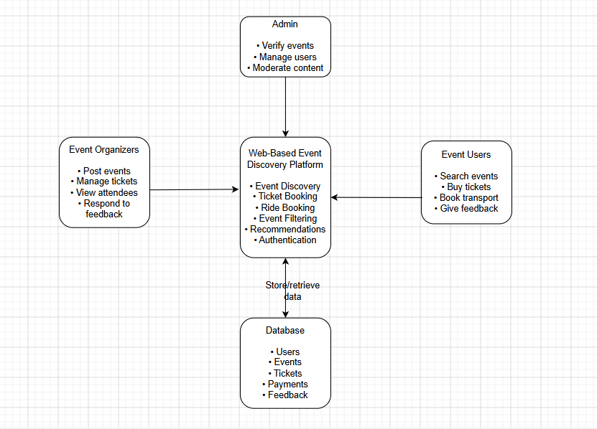
Figure 1: Conceptual Model

Chapter 3: Methodology

3.1 Introduction
This chapter covers the design technique to be implemented when designing the proposed system. Moreover, system methodology, analysis & design, development tools, techniques, and deliverables will also be defined in this chapter.

3.2 System Methodology
The system methodology of choice for undertaking this project will be Object-Oriented Analysis and Design (OOAD), which is a method of building software by modelling it as an interaction of objects. Unified Modelling Language (UML) diagrams are often used to visualize the system to understand how objects interact and provide a solid base for development of the system.
The Agile developmental model will be used in the development of the system. It is a suitable approach for the proposed system as it is very flexible and allows fast delivery of the finished system within the stipulated amount of time. New or changing requirements can be implemented even after the prototype is released, and improvements can be made due to continuous testing and debugging.
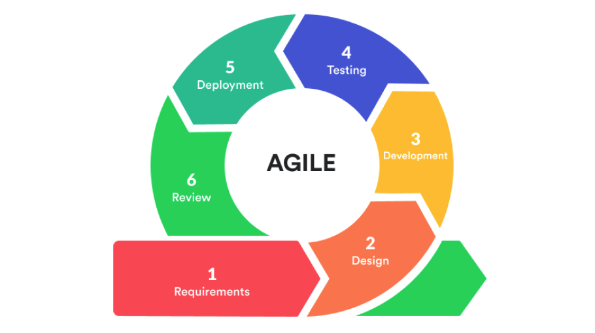
Figure 2: Steps in Agile Software Development (What is Agile Development?, 2021)

3.2.1 Requirements Gathering
The first step involves requirements elicitation and gathering from relevant stakeholders for the proposed system. User requirements and specifications will be collected via various methods including surveys, interviews, and questionnaires. The gathered requirements will then be analyzed and verified, and a final requirements document will be produced to aid in the design process.

3.2.2 Design
This step involves designing abstract models of the proposed system architecture, components, data models, and interfaces. Requirements gathered from stakeholders will be used in designing these abstract models, which provides fundamental information on how the proposed system code will be developed.

3.2.3 Development
Using the models designed in system design, the code for the proposed system is generated, taking into consideration factors such as constraints, time, manpower and resources. Such factors determine the final quality of code produced for the first prototype of the proposed system.

3.2.4 Testing and Debugging
This step requires the use of relevant tools and technologies to test the generated code for the proposed system to ensure user requirements are properly implemented and that the system displays working functionality.

3.2.5 Deployment
After the conclusion of testing and debugging, a working prototype of the proposed system is then released after ensuring the system works as expected and effectively meets user requirements.

3.2.6 Review
After deployment, stakeholders and other users of the system offer feedback based on their personal experience with the system; expressing their satisfaction, the quality of the system, overall user experience and efficiency of the system. Improvements suggested by users of the system are considered, and the agile development cycle begins again from requirements elicitation, iteratively until a final finished system is fully developed.

3.3 System Analysis
This involves studying the system to understand its workings, functionality, scope, and estimate potential improvements. This section outlines the breakdown of the UML tools and techniques that will be used to analyse the system, namely the use case diagram, class diagram, and the context diagram.

3.3.1 Use Case Diagram
The UML Use Case Diagrams are used to model how different users interact with the proposed system. It is used as a support to requirements elicitation and gathering as it visually represents how users expect to interact with the system.

3.3.2 Class Diagram
Class diagrams are object-oriented models that show the classes present in a system and the relationship between those classes. This will help in understanding how each class interacts with the other and provides a definitive model from which efficient and structured code can be produced.

3.3.3 Context Diagram
The context diagram is used to outline what happens outside the system boundaries. They are used to show other systems that rely on or are relied on by the proposed system. System boundaries help in filtering user requirements that are achievable, which are finally used in generation of code for the system.

3.3.4 Entity Relationship Diagram
The ERD allows for modelling database designs, offering a graphical representation of the database structure. As the name suggests, it identifies entities present in a system and gives the relationship between those entities.

3.4 System Design
This section aims at laying down models that meet requirements for the system while describing its processes. Such models are depicted using database schema, wireframes, and system architecture.

3.4.1 Database Schema
Database schema offers a representation of how data in a relational database is organised; inclusive of logical constraints such as table names, fields, data types and relationships between these entities (IBM, n.d.). The constraints will be used in developing the database for the system.

3.4.2 Wireframes
Wireframes are two-dimensional illustrations that serve as the skeleton or framework of a website or application, showing the structure, layout, and functionality without focusing on aesthetics. They are a fundamental visual concept in web development and UI design (Wireframes, 2025). Wireframes will assist in designing the UI/UX of the proposed system.

3.4.3 System Architecture
This refers to the conceptual model that defines interactions between components in a system, the system’s structure, and behaviour (Tiwari, 2025). Within the proposed system, this will help model the structure by illustrating user interactions and explaining how the system processes and provides the requested information.

3.5 System Development Tools and Technologies
This section will cover the various tools and technologies that will be used in building the proposed system, taking into consideration their usefulness in developing the system.

3.5.1 React.js
React.js is an open-source JavaScript library, widely used for building dynamic and interactive user interfaces for web applications. React employs a component-based architecture, enabling developers to build reusable UI elements that update efficiently in response to data changes through its virtual DOM mechanism (React, n.d.). React has been extensively adopted in the development of event-driven and data-intensive web applications due to its performance efficiency and developer-friendly ecosystem. Its use in the proposed platform will facilitate the creation of a responsive and interactive frontend that provides users with seamless event browsing and management experience.

3.5.2 Node.js
Node.js is a server-side JavaScript runtime environment built on Chrome's V8 engine, designed to enable the development of scalable and high-performance network applications. Unlike traditional server-side technologies, Node.js operates on a non-blocking, event-driven I/O model, making it particularly well-suited for handling concurrent requests in real-time web applications. Node.js has been widely applied in the development of RESTful APIs and backend services for web platforms, including event management systems (Introduction to Node.js, n.d.). In the context of the proposed platform, Node.js will serve as the backend runtime environment, handling API requests, business logic, and communication between the frontend and the database.

3.5.3 MySQL
MySQL is a widely used open-source relational database management system (RDBMS) that stores and manages structured data using Structured Query Language (SQL). It is known for its reliability, scalability, and ease of integration with web development frameworks (Erickson, 2024). Relational databases such as MySQL are particularly appropriate for applications that involve structured data with clearly defined relationships, such as events linked to categories, organizers, and attendee records. MySQL's support for complex queries, indexing, and transactional integrity makes it a suitable choice for the proposed platform's data layer, where event listings, user profiles, and RSVP data will need to be stored and retrieved efficiently

3.5.4 GitHub
GitHub is a web-based social coding platform that supports collaborative software development. It provides tools for version control, code review, and issue tracking among others (Coursera Staff, 2025). In the context of development of the proposed system, GitHub will be used to maintain proper collaboration and provide an easier environment for code debugging.

3.5.5 Postman
Postman is a platform for API development and testing that allows for creation of collections, automating tests, and monitoring performance of APIs (Caraffa, 2025). Postman will be used to create and test APIs that will be used throughout the system.

3.6 Deliverables
This section defines the various deliverables that will be delivered to meet user requirements

3.6.1 Authentication Module
This allows users to create accounts and sign into the platform, while also providing security to prevent unauthorized access to accounts.

3.6.2 Events Module
This module will allow users to view events around their area and purchase tickets for events.

3.6.3 Organiser Module
This module allows event organisers to post their events on the platform and list ticket prices for their events.

3.6.4 Transport Module
This module will allow users to schedule rides to and from the event via the platform depending on the event selected.

Chapter 4: System Analysis and Design

4.1 Introduction
This chapter explores the analysis and design of the system in depth by defining and describing the various design diagrams used in building the Web Based Event Discovery Platform. The system’s main goal is to provide an efficient source for Nairobi residents to discover and purchase tickets for various events.

4.2 System Requirements
The required functionalities of the system are outlined below and split into functional and non-functional requirements.

4.2.1 Functional Requirements
The functional requirements that the system has to offer include:
- Authentication
This is a requirement that ensures users can create or log in to their accounts on the website with a guarantee that their accounts are safe from unauthorised access. The authentication module is responsible for delivering this requirement.
The authentication module, for creating an account, requires the user’s email and phone number. OTP verification is used by sending a one time code to the user’s email or via SMS. Upon confirmation of the OTP, the authentication module prompts the user to enter and confirm the password they will use to access their account, then furthermore prompts the user to add a recovery method for two-factor authentication.
For logging in as an administrator, the authentication module prompts for the username and password, and the data is compared to fields in the database, and once a matching row is found, the system grants access to the administrator.
- View Events Functionality
This is a requirement that allows all users of the platform to view events in and around their area based on their location. It also allows users to filter events based on certain constraints like date, location, price, etc.
- Purchasing tickets functionality
This is a requirement that allows users to purchase tickets for various events that they wish to go to. Tickets are broken down according to their price and services that will be offered with the purchase of each ticket (VIP tickets, regular tickets, group tickets, etc.). Users are allowed to purchase any number or available tickets, both on and before the day of the scheduled event.
- Posting events functionality
This feature has been made available to event organizers, allowing them to post events they have organized on the platform. Organizers are able to set ticket prices, add descriptions about their events and view the number of people that have purchased tickets for their events.
- Feedback functionality
This is a feature that allows eventgoers to post feedback and reviews of events that they have attended, while also allowing event organizers to view reviews about their events and make necessary plans to satisfy eventgoers. Feedback on the website functionality and convenience is also made available to both eventgoers and event organizers on the platform, giving users a chance to recommend changes and improvements to the website.
- Ride Scheduling Functionality
This feature allows eventgoers to schedule rides to and from events in advance without the hassle of looking for rides and taxis on the day of the event. As many people attend events, especially concerts, finding rides is a hassle since a large number of people tend to order taxis from the same application. Scheduling rides in advance through the platform enable eventgoers to avoid the unnecessary hassle of locating taxis after the conclusion of events.

- View Event History Functionality
This functionality is made available to eventgoers on the platform, allowing them to view their history of events (attended events, pending events), as the system fetches the information from the database and presents it to the user.

4.2.2 Non-Functional Requirements
In addition to the functional requirements, non-functional requirements offered by the system include:
- Security
This requirement guarantees the security of each user’s data from leaking or exploitation by cyber attacks, malware, potential system crashes and unauthorized access. The system uses two factor authentication by sending an OTP via either SMS message or an email to the user. This two factor authentication enables each user to be matched with 2 unique fields, their phone number or email and their username, thus preventing creation of fake accounts using existing user credentials. This also prevents unauthorised logging in to user’s accounts.
- Performance
This requirement ensures that the performance of the system is always up to standard for users of the platform. This has been made possible by implementing browser caching, which allows frequently used or visited resources to be stored locally so that repeat visits are fast. Moreover, asynchronous operations have been implemented, so that operations can be carried out concurrently without waiting on each other.
- Usability
This requirement defines how easy the platform is to be used by any user. The design of the platform has been made in a clear and simple manner, with icons and buttons clearly labelled and processes being easy to follow and carry out. Furthermore, features common in other systems as well as widely known frameworks were also used in designing the system, making users feel familiar with objects and elements on the platform.

- Maintainability
This requirement outlines how fast and efficiently errors and crashes in the system can be identified and resolved to return to normal functionality. The system’s documentation allows for easy troubleshooting of the system, while AI has been integrated as well to quickly find errors in the platform’s code for quick correction by the developers.
- Availability
This requirement outlines that the platform will be made available to users and any given point in time, regardless of their location in Nairobi. Being a web application, users are kept logged in to the website, even after leaving the website or closing the browser, using session cookies. Expiration of these session cookies will just simply require the user to log in again to continue using the services offered by the platform.
- Scalability
This requirement defines how the system grows as the number of users or data increases. This has been recognised by the utilisation of a MySQL database that provides easy scaling.

4.3 System Analysis Diagrams
In this section, diagrams have been utilised to give descriptions on how the system will meet requirements, the system’s functionality and the structure of the system itself. Diagrams included in this section are the use case diagram, class diagram, entity relationship diagram, wireframes and context diagram.

4.3.1 Use Case Diagram
The diagram below shows the use case diagram of the system. The actors are the eventgoers,
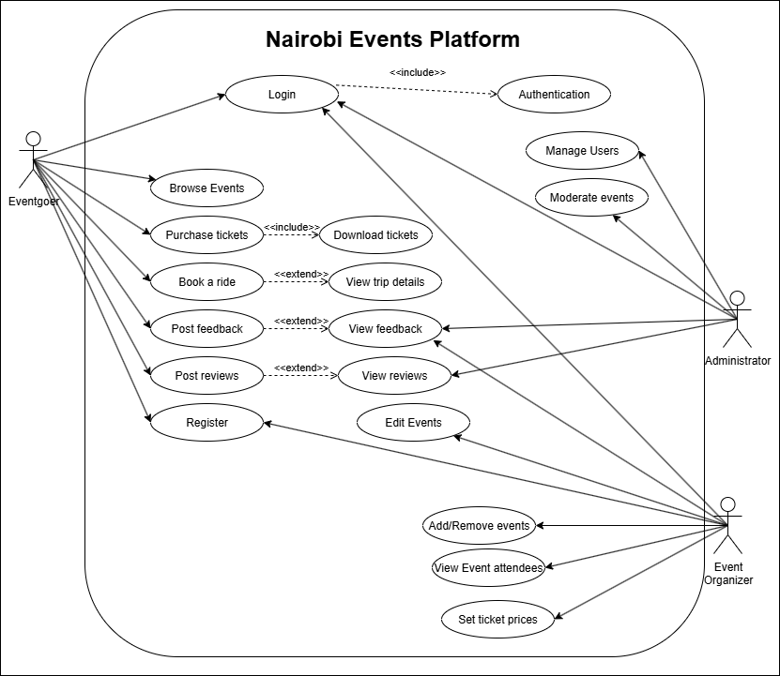
event organizers and system administrators. The use case diagram depicts the interaction between the users and core functionalities. Eventgoers are responsible for purchasing and downloading tickets, viewing events and booking & tracking rides. Event organisers can post, edit and delete their events while viewing reviews and setting prices for the events, while the system administrators carry out basic CRUD functionality on entities in the system.
Figure 3: Use Case Diagram

4.3.2 Context Diagram
The diagram below depicts the context diagram which shows everything that interacts with the system. Eventgoers, event organizers and the administrators are the active users of the system. Email service and mobile service are both utilised for OTP verification. M-Pesa APIs (Daraja) facilitate payments directly from the platform, while Uber API offers ride booking directly on the platform.
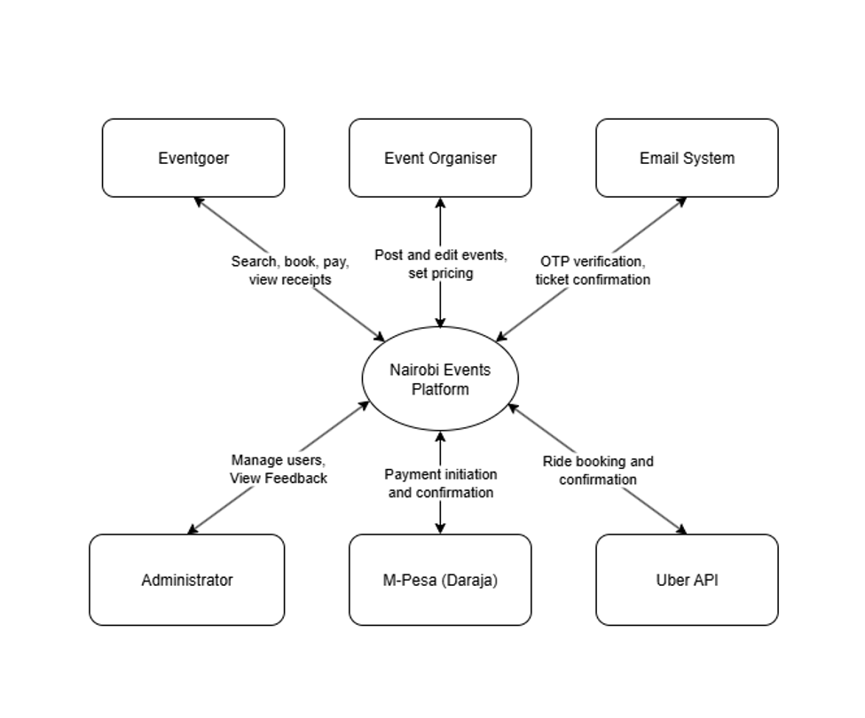
Figure 4: Context Diagram

4.3.3 Class Diagram
The diagram below shows the class diagram of the system, depicting the various classes, their attributes and methods, and how they relate to one another. The User class acts as the base class, holding common attributes such as name, email, password and role, alongside methods for logging in, logging out and updating a profile. The Eventgoer, Organiser and Admin classes all inherit from the User class, each with attributes and methods specific to their role. Eventgoers can browse events, purchase tickets, write reviews and request rides, while organisers are responsible for posting, editing and deleting events and viewing their bookings. Admins are responsible for managing users, moderating events and viewing feedback.
The Event class is associated with Category and Venue, which define the type of event and where it is held respectively. Each event can have multiple Ticket types (such as regular and VIP), and each ticket can be reserved through one or more Booking records made by an eventgoer. Each booking is linked to a Payment, which records the payment method, amount and status of the transaction. Eventgoers may also leave a Review for events they have attended and submit a Ride Request linked to a specific event for transport to and from the venue.
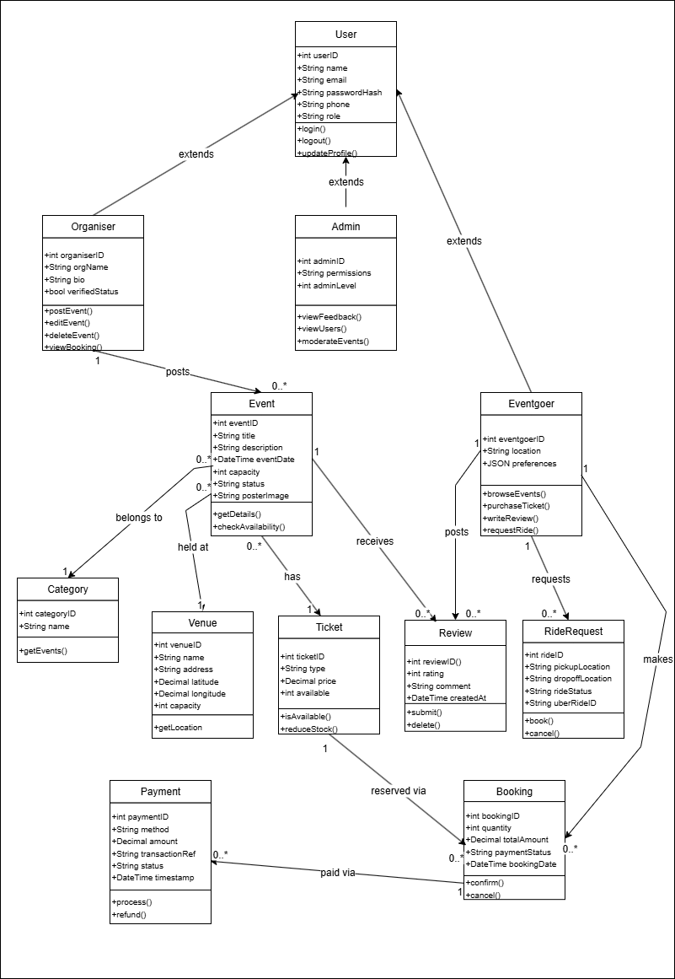
Figure 5: Class Diagram

4.3.4 Entity Relationship Diagram
The diagram below shows the entity relationship diagram of the system, which forms the basis of the database design. The USER entity stores common account information and is linked to the EVENTGOER, ORGANISER and ADMIN entities through one-to-one relationships, allowing each user account to take on a specific role within the system. Organisers post EVENT entities, with each event linked to a CATEGORY and a VENUE. Each event can have multiple TICKET entries, which differ in type, price and quantity available.
Eventgoers make BOOKING entries for tickets, with each booking linked to a PAYMENT entry that records the transaction details once payment is completed via M-Pesa. Eventgoers can also submit REVIEW entries for events they have attended, and RIDEREQUEST entries for transport booked through the platform. These relationships ensure that all activity carried out by eventgoers, organisers and admins on the platform can be traced back to a single user account.
Figure 6: Entity Relationship Diagram

4.4 System Design
This section outlines the design of the system based on the analysis carried out in the previous section. The diagrams included here are the database schema, wireframes and system architecture, which translate the requirements and analysis diagrams into the actual structure and appearance of the system.

4.4.1 Database Schema
The diagram below shows the database schema of the system, derived from the entity relationship diagram. Each entity in the ERD is represented as a table in the MySQL database, with PKs uniquely identifying each record and FKs used to maintain relationships between tables. For example, the EVENT table contains foreign keys referencing the ORGANISER, CATEGORY and VENUE tables, while the BOOKING table references both the EVENTGOER and TICKET tables. This structure allows the system to retrieve related data efficiently, such as fetching all tickets and reviews for a specific event, or all bookings made by a specific eventgoer.
Figure 7: Database Schema

4.4.2 Wireframes
1. Homepage
The diagram below shows the wireframe of the homepage, which serves as the main entry point for eventgoers. The page includes a search bar for locating specific events, filter tags for narrowing down events by category, and a grid of event cards displaying the event name, date, venue and starting ticket price.
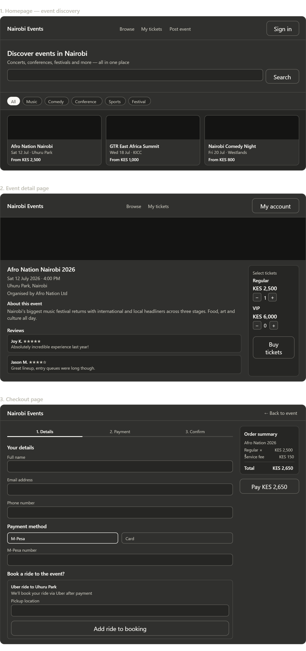
Figure 6: Homepage Wireframe
2. Event Detail Page
The diagram below shows the wireframe of the event detail page, which displays full information about a selected event, including its description, date, venue and reviews left by previous attendees. A ticket selection panel is provided alongside the event details, allowing eventgoers to choose the ticket type and quantity before proceeding to purchase.

Figure 7: Event Detail Page Wireframe
3. Checkout Page
The diagram below shows the wireframe of the checkout page, where eventgoers enter their details, select a payment method and complete payment via M-Pesa. An optional ride booking section is also included on this page, allowing eventgoers to request a ride to the event venue as part of the same checkout process. An order summary panel displays the total cost of the booking before payment is made.

Figure 8: Checkout Page Wireframe

4.4.3 System Architecture
The diagram below shows the system architecture, which follows a three-tier structure made up of the frontend, backend and database. The frontend is built using React.js and consists of the pages that users interact with, including the events page, booking page, organiser dashboard and admin panel. These pages communicate with the backend through a REST API built using Node.js and Express, which is split into modules handling authentication, events, bookings and transport. The backend processes requests from the frontend, communicates with the MySQL database to store and retrieve data, and integrates with external APIs, namely M-Pesa (Daraja) for processing payments and the Uber API for booking rides to and from events.
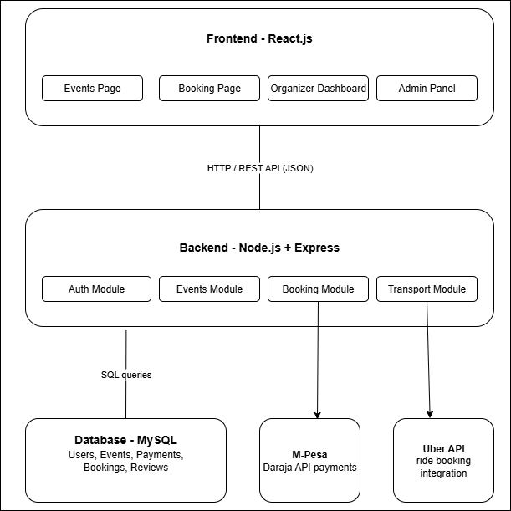
Figure 9: System Architecture

References
(n.d.). Retrieved from ticketsasa.com: https://www.ticketsasa.com/events
(n.d.). Retrieved from developer.safaricom.co.ke: https://developer.safaricom.co.ke/
(2022). Retrieved from nairobi.go.ke: https://nairobi.go.ke/wp-content/uploads/City-Culture-Arts-Tourism-Sub-Sector.pdf?utm_source=chatgpt.com
(2026). Retrieved from whats-on-nairobi.com: https://whats-on-nairobi.com/
Abuya, K. (2025, April 8). Retrieved from techcabal.com: https://techcabal.com/2025/04/08/gig-wants-to-turn-one-time-eventgoers-into-lasting-communities
Afrinovation Festival Nairobi. (2025). Retrieved from vabu.app: https://vabu.app/afrinovation-festival-nairobi
ARouterContinua. (2025). Mookh Ticketing Website. Retrieved from reddit.com: https://www.reddit.com/r/nairobitechies/comments/1mujguq/mookh_ticketing_website
bingadeh. (2026, March). Retrieved from reddit.com: https://www.reddit.com/r/KenyaStartups/comments/1rsnk1l/i_built_a_platform_to_help_people_discover_whats/
Caraffa, A. (2025, September 19). Postman: what it is and how it works. Retrieved from openapi.com: https://openapi.com/blog/postman-what-it-is-and-how-it-works
Coursera Staff. (2025, September 16). What Is GitHub? Use Cases and FAQ. Retrieved from coursera.org: https://www.coursera.org/articles/what-is-github?isNewUser=true
Editor, T. (2024, May 8). The Nairobi International Cultural Festival Returns for its 9th Edition in June 2024. Retrieved from kenyabuzz.com: https://kenyabuzz.com/lifestyle/the-nairobi-international-cultural-festival-returns-for-its-9th-edition-in-june-2024
Erickson, J. (2024, August 29). MySQL: Understanding What It Is and How It’s Used. Retrieved from oracle.com: https://www.oracle.com/africa/mysql/what-is-mysql/
IBM. (n.d.). Database Schema. Retrieved from ibm.com: https://www.ibm.com/think/topics/database-schema
Introduction to Node.js. (n.d.). Retrieved from nodejs.org: https://nodejs.org/learn/getting-started/introduction-to-nodejs
Milimo, D. (2026). List of International superstars who performed in Kenya in 2025. Retrieved from mpasho.co.ke: https://www.mpasho.co.ke/entertainment/2026-01-01-list-of-international-superstars-who-performed-in-kenya-in-2025
React. (n.d.). Retrieved from w3schools.com: https://www.w3schools.com/react/
Tiwari, V. (2025, February 7). Understanding System Architecture: A Beginner's Guide. Retrieved from medium.com: https://medium.com/@vaibhavtiwari.945/understanding-system-architecture-a-beginners-guide-d2aad48f0007
What is Agile Development? (2021, May 25). Retrieved from indevlab.com: https://indevlab.com/blog/what-is-agile-development/
Wireframes. (2025). Retrieved from awork.com: https://www.awork.com/glossary/wireframe

Appendix

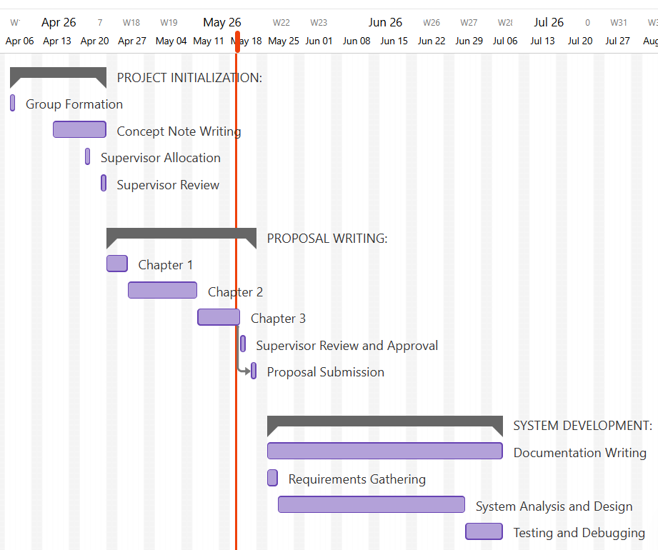
Figure 10: Gantt Chart showing progress of the system’s development

